# CU

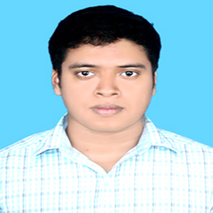

# CURRICULUM VITAE

**MD. YOUSUF**

Road # 139/1, Road # 19, Shara Kutir,

Modhubazar, Dhanmondi, Dhaka-1209

Cell: +880 1717959810

E-mail: [mohammodsf@gmail.com](mailto:mohammodsf@gmail.com)

# Career objective

* To build up my career in the field of some challenging post in any organization where there is immense scope to work and prove ones expertise and to maneuver positive contribution in the organization by sincerely accomplishing the duties and responsibilities assigned to me.

# Academic Qualification

**Masters of Arts (MA) :**

Institute : Dhaka College.

Affiliated : National University**.**

Subject : English

Result : Running

**Bachelor of Arts (BA) :**

Institute : Noakhali Govt. College.

Affiliated : National University**.**

Subject : English

Result : 2.96 out of 4.00

**Higher Secondary Certificate(H.S.C) :**

Institute : Dhaka Commerce College.

Group : Business Studies.

Board : Dhaka

Passing Year : 2009

Result : G.P.A- 4.50 out of 5.00

**Secondary School Certificate(S.S.C) :**

Institute : Saptagaon Adarsha High School

Group : Business Studies.

Board : Comilla

Passing Year : 2007

Result : G.P.A- 4.81 out of 5.00

# Computer Skills

* Microsoft Office Programs (Word, Excel, PowerPoint)

# Other personal details

Father’s Name : Md. Baharul Alam

Mother’s Name : Rahima Begum

Date of Birth : 01-07-1992

Nationality : Bangladeshi (By Birth)

Religion : Islam

Sex : Male

Marital Status : Single

Blood Group : O +ve

Permanent Address : Village: Sundorpur, Post: Chatkhil,

P.S: Chatkhil. Dist: Noakhali.

Post Code: 3870;

# Language Ability

* English(Full professional proficiency).
* Bengali (Native).

# Self Assessment

* Excellent negotiation, interpersonal communication skills.
* Effective presentation skills.
* Being able to interest with people at all levels & work as a team player.
* Like to take challenges & ready to work under pressure.

# Interests and hobby

* Travelling and Sports.

# Declaration

I do declare that all the information mentioned above is true and correct to the best of my knowledge.

C:\Users\mehedeee\Desktop\ROBIN\aa_new.jpg

Signature